1. *What is your favorite quote from the "Still Manifesting Feminism" section and why? What does this quote evoke in you? Why do you think this quote resonates with you most?*

The quote I found most interesting from the ‘Still Manifesting Feminism’ chapter is, “They wondered if they were ‘allowed’ to be feminists – and challenged us to ponder that, too.” This quote summarizes something that every feminist struggles with accepting and teaching, which is why it stood out to me. The paragraph before this quote discussed some mistakes the authors had been criticized for including the limiting discussions on trans issues and how limited the authors perspectives were on the subject. The authors abilities to notice their mistakes and over sights is something that always comes with feminism. It’s incredibly difficult to include all minorities into the discussion all the time, that sometimes groups are left out. Realizing mistakes is one of the first steps to becoming a feminist, and I love the authors for addressing that.

2. *After reading their introductions, who do you connect with more, Jennifer or Amy? You must choose only one of them. Give TWO specific reasons why and extend this discussion. What is it about these points that resonate with you?*

After reading the introductions of both authors, I relate to author Jennifer more. First, Jennifer’s family life is more similar to mine which I think has something to do without similarities. Jennifer also has a very personal opinion on abortion stances because of her experience with her sister’s abortion. I also hold very strong opinions about abortion and similar feelings, like the disgust of judgement and pride for helping someone. Jennifer also implies in most of her arguments that there is a strong form of patriarchy influencing these events, which resonates with me too. I also think about factors that could be persuading an argument and the back story behind people that make them a certain way.

3. *Name ONE point from "A Day Without Feminism" that is the most poignant. Why did you select this point? What is it about this point that sticks out to you? How can you see this has changed/not changed in present day?*

A truly interesting point from ‘A Day Without Feminism’ is the gendered help wanted signs. It’s so interesting reading about these awkward injustices that aren’t often recognized. I knew that women were predominately hired for positions like secretary, teacher, and domestic workers, but I didn’t know signs were gendered. I assumed that women and men both knew what jobs were for them, but the authors made the great point that if you were a female lawyer, you’d have to search the help wanted male ads in order to get a job. I also like how they keep the idea going in the whole chapter that we are living in 1970. This isn’t often observed by third wave feminists who have never experienced this forced lifestyle.

4. *As you read "The Dinner Party," I'm sure you will have questions about specific references. For instance, in their intro to this chapter, Baumgardner and Richards mention Thelma and Louise (1991). Really, Baumgardner and Richards make so many contemporary references in this chapter, and these are so crucial to your understanding the movement and their points in reference to this amazing dinner feminist dinner party.*

Sappho- In the chapter, they say this person would be a dinner guest to ‘the dinner party’, but I had no idea who they were. Sappho is a Greek lyric poet often referred to as the tenth muse. She is highly regarded for her poetry and writings, 650 of which still survive today.

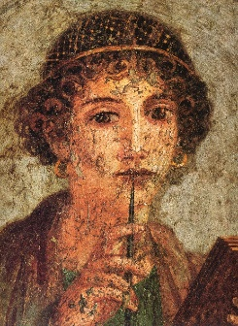

Me’shell Ndege’ocello- she’s an American singer-songwriter known for sparking the neo-soul movement. Her birth name is Michelle Lynn Johnson, and the name above is her stage name, taken later in her career.

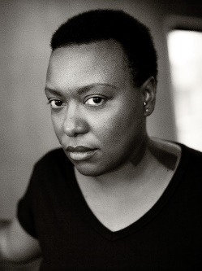

Susan Brownmiller- An American feminist journalist best known for her book *Against Our Will*, which is known as one of the 100 most important novels of the twentieth century. The book discusses that men have previously defined rape and the issues involved with said definitions.

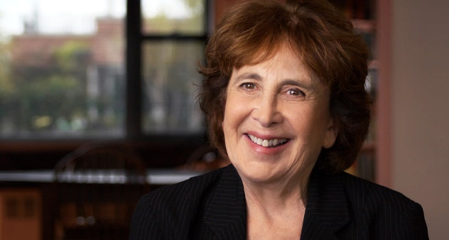

Radclyffe Hall- An English poet and author born in 1880 who wrote the groundbreaking lesbian novel, *The Well of Loneliness*.

